# 

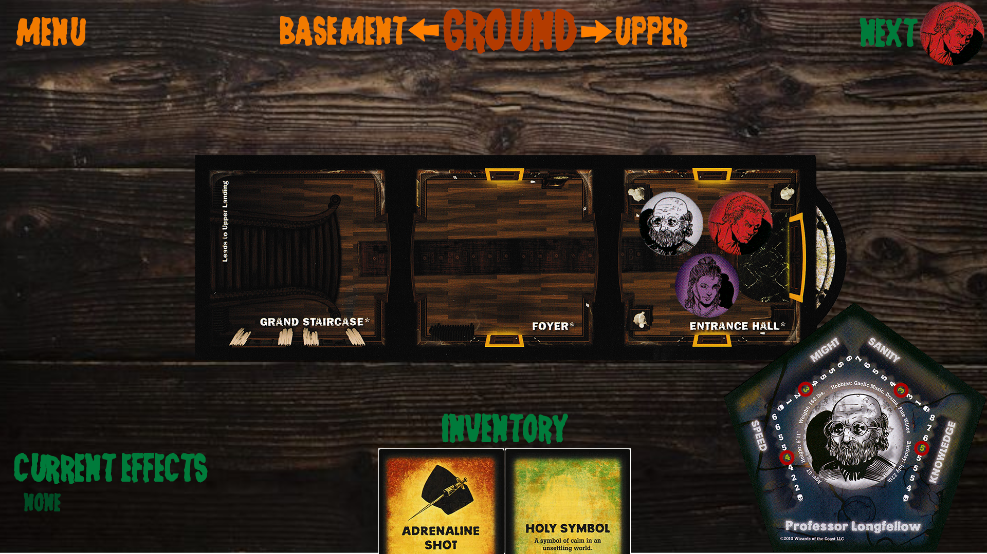

## 

Project Name: Betrayal at the House on the Hill Online (Betrayal Online)

This project is a video game adaptation of the strategy board game *Betrayal at the House on the Hill - 2nd Ed.* by Bruce Glassco.

This project will adapt the board game into a 2D web-based multiplayer game, that allows 3-6 players to enter as explorers to face the uncertainties of a haunted house. Players will choose between various characters with varying stats and histories. Players will experience events, acquire items, and face omens while exploring various rooms that are procedurally placed throughout the house. At some point during the game, the Haunt occurs, turning one of the explorers into a Traitor. The Traitor will then attempt to use their newfound powers to kill the remaining Heroes, while the Heroes attempt to thwart the Traitor’s evil plan.

The players take turns in controlling their character to traverse the haunted house. Each player has their own inventory to collect any Items or Omens that they find. The game keeps track of four stats that change throughout the game that will be useful when encountering certain events or activities in the haunted house. There are three floors to the haunted house, with rooms that lead between each floor. Rooms are procedurally placed when exploring through an open doorway. The Haunt will start once a certain Omen is found, and then win conditions will be presented to the Traitor and Heroes that, once complete, will mark the end of the game.

1. What are your feelings about these Main Menu concepts? What would you change about them? Which one do you prefer?
2. What are your feelings about this In-Game User Interface concept? What aspects do you want to be kept, and what aspects do you want to be changed?
3. What features or information would you like available to you if you were to play a demo or final release of this game?
4. Do you have any other questions, comments, or concerns?